Heinrich Hertz Technical Paper 2020

By James Duffy (17206286) and Eoin Flynn (15179818)

University of Limerick
E-mail: 17206286@studentmail.ul.ie
15179818@studentmail.ul.ie

ABSTRACT

Put your abstract here… It should be concise, no more than 300 words.
Before the abstract, the authors’ names should be centered below the title and should be in Time New Roman 12 points. The address should be centered below the author’s name and should be in Time New Roman 10 points. Please include your E-mail address. The initial title should be centered across the top of the first page and should be in Time New Roman Bold 18 points.

I. Introduction

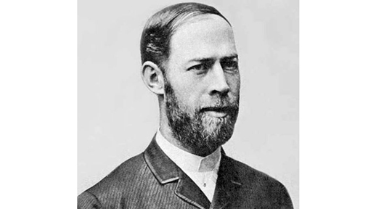

Figure 1.1 – Heinrich Hertz
Heinrich Rudolf Hertz was born in February 22, 1857 in Hamburg and died January 1, 1894. He showed that the Scottish physicist James Clerk Maxwell’s studies and theory on electromagnetism was indeed correct, proving that light and heat are forms of electromagnetic radiation.
The unit of frequency, cycles per second, was named after him. [1]

II. Background

A. Subsection Title

Provide figures with their captions within the text. All illustrations and pictures should be high-contrast black and white (not color) prints.
References should be cited, at the end of the paper, in numerical order in which they appear in the text. When citing reference in the text, type the corresponding number in square brackets as shown at the end of this sentence: [1]. References should be complete and in standard IEEE style.

B. Instructions for 8 ½’’ x 11’’ paper :

The distance from the top edge of the paper to the top of the first line (i.e., the title) should be 23 mm. Left and right margins should be the same (19 mm). The width of each column should be 84 mm. The distance between the two columns of the text should be 10 mm. The distance from the bottom edge of the paper to the bottom of the last line of type on all page should be no less than 20 mm ; this allows room to insert the copyright notice and page numbers in the final version.

C. Instructions for A4 paper:

The distance from the top edge of the paper to the top of the first line (i.e., the title) should be 30 mm. Left and right margins should be the same (16 mm). The width of each column should be 84 mm. The distance between the two columns of the text should be 10 mm. The distance from the bottom edge of the paper to the bottom of the last line of type on all page should be no less than 26 mm ; this allows room to insert the copyright notice and page numbers in the final version.

III. Influences

IV. Technological Achievements
- Electromagnetic waves
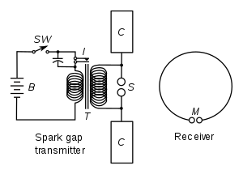
Figure 4.1 – Diagram illustrating apparatus for generating and detecting radio waves. A spark transmitter with a spark gap is powered by high voltage pulses from a Ruhmkorff coil (denoted as T in the diagram). The receiver consists of a spark gap and a loop antenna.

In autumn of 1886 Hertz noticed that discharging a Leyden jar (an early day capacitor). He used a Ruhmkorff coil (a type of transformer used to produce high voltage pulses from low DC supplies) driven spark gap (radio transmitter that produces radio waves by means of a spark) as a radiator. His receiver was consisted of a loop antenna and a micrometer spark gap (a device used to measure potential in an electrical circuit [X]

- Dipole Antenna (Applications-Rabbit ears)
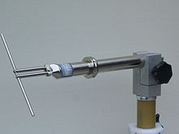
Figure 4.2 – UHF half-wave dipole.
The dipole is the simplest type of antenna, invented by Hertz. It simply consists of two conductors of equal length in the end-to-end orientation with feedlines connecting the two. [Y] This invention allowed him to detect the electromagnetic waves and is used to help create figure 4.3 below.
A. Rader
B. Wireless telegraphy
C. Dipole antenna
D. Radio transmitter
V. Impact and Applications
“I do not think that the radio waves I have discovered will have any practical application.”

X. CONCLUSIONS

The conclusions of your paper. Future work directly from the paper is also acceptable.
This Word template for A4 pages has already defined styles for use in the paper.

REFERENCES

[1] IEC History. Iec.ch.
[2] C.D. Author, "Paper Title", Journal, vol. 8, 1997, pp. 1-10.
[3] E.F. Author, "Paper Title", in Proceedings of Conference, 1996, pp. 30 -34.
[X] The creation of scientific effects : Heinrich Hertz and electric waves. Chicago: University of Chicago Press. 1994. ISBN 9780226078915. OCLC 704274080. Retrieved September 25, 2015.
[Y] Stutzman, Warren; Thiele, Gary (1981). Antenna Theory and Design. John Wiley & Sons, Inc. pp. 212–220. ISBN 0-471-04458-X.

